|  |  |
| --- | --- |
| Assignment Date | 25 September 2022 |
| Student Name | Bharath Kumar K |
| Student Roll Number | 731619104009 |
| Maximum Marks | 2 Marks |

# Solution:

Task 1: Sales by Customer:

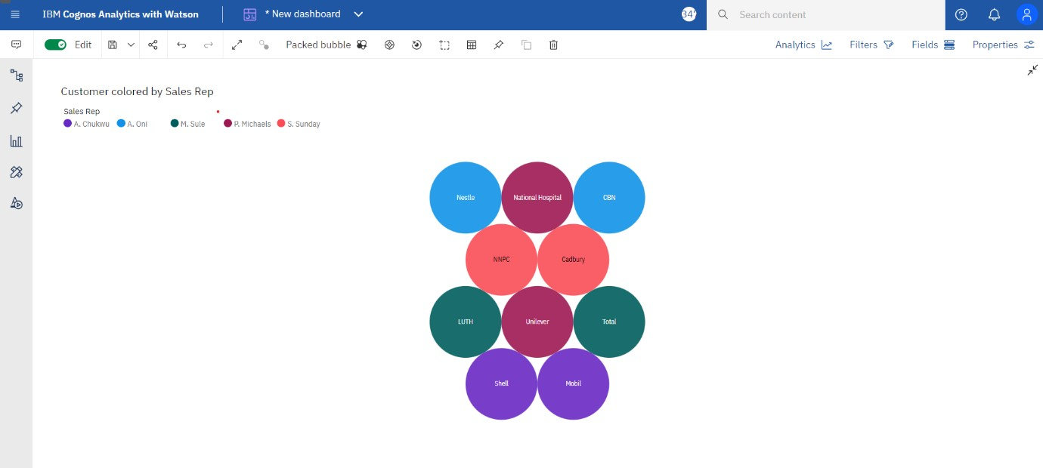

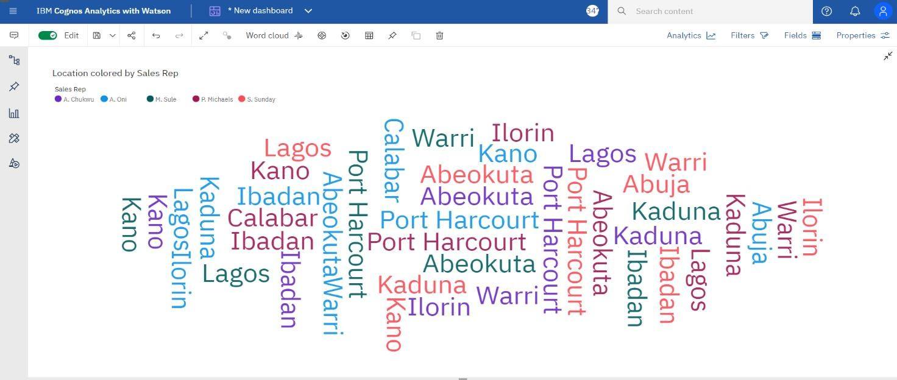

Task 3: Sales by Sales Representative:

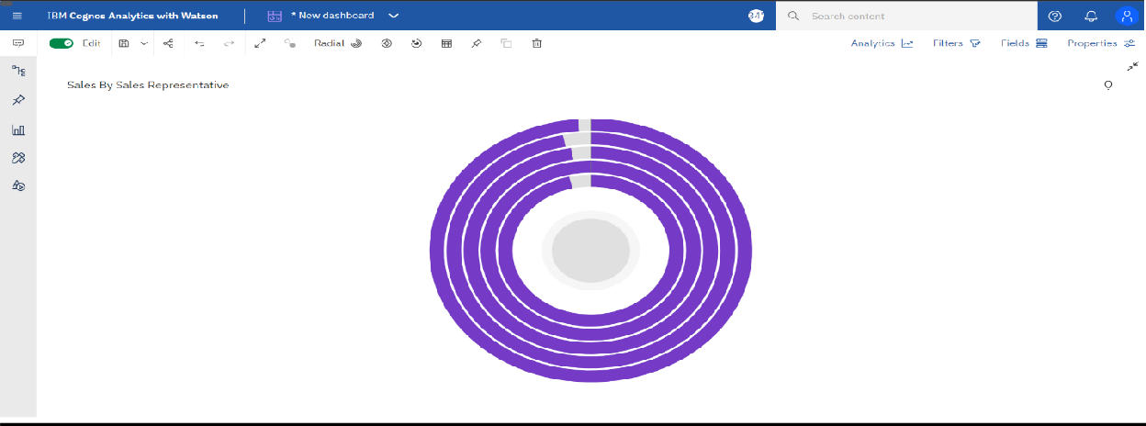

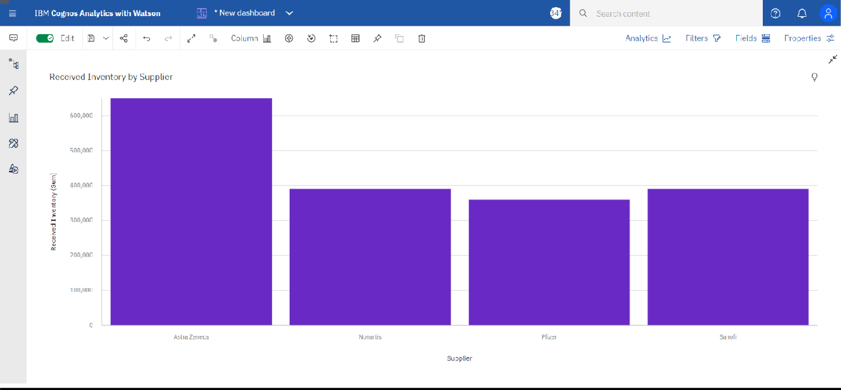

Task 5: Inventory Stock for Warehouse Locations:

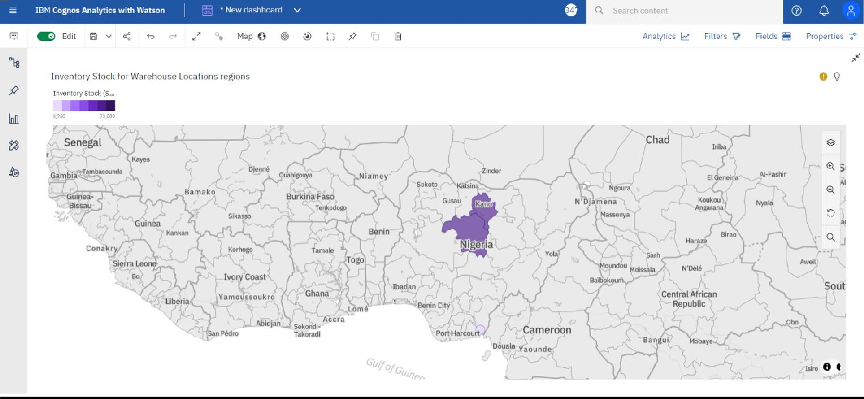

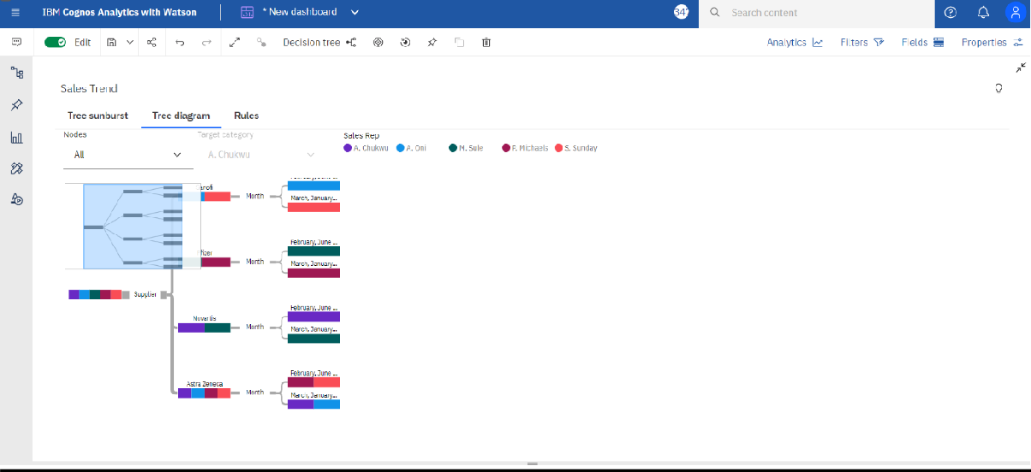

Task 7: Monthly Sales:

